CHAUDHARY HAMDAN

1905387

Networks Lab 1

08/07/2021

1. Write a C program to swap the content of 2 variables using pointer.

Code:

#include<stdio.h>

int main() {

int a = 1, b = 2;

printf("a = %d, b = %d\n", a, b);

int *aptr = &a;

int *bptr = &b;

int temp = *aptr;

*aptr = *bptr;

*bptr = temp;

printf("a = %d, b = %d\n", a, b);

return 0;

}

Output:

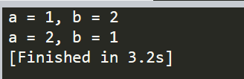

1. Write a C program to assign values to each members of the following structure. Pass the populated structure to a function Using call-by address and print the value of each member of the structure with in that function.

struct info{

int roll_no;

char name[50];

float CGPA;

}

Code:

#include<stdio.h>

#include<string.h>

struct info {

int roll_no;

char name[50];

float CGPA;

};

void print(struct info *stud) {

printf("Roll Number: %d\n", stud->roll_no);

printf("Name: %s\n", stud->name);

printf("CGPA: %.2f\n", stud->CGPA);

}

int main() {

struct info stud;

stud.roll_no = 1905387;

strcpy(stud.name , "Hamdan");

stud.CGPA = 9.60;

print(&stud);

return 0;

}

Output:

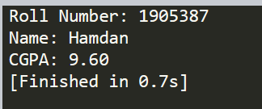

1. Write a C program to extract each byte from a given number and store them in separate character variables and print the content of those variables

Code:

#include<stdio.h>

int main() {

int a = 256;

int mask = 0xff;

unsigned char arr[4];

for (int i = 0; i < 4; i++) {

arr[i] = a & mask;

a >>= 8;

}

for (int i = 3; i >= 0; i--) {

printf("%d, ", arr[i]);

}

return 0;

}

Output:

3

1. Write a C program to check whether the Host machine is in Little Endian or Big Endian.

Code:

#include<stdio.h>

int main()

{

int i = 1;

char *c = (char*)&i;

if (*c == 1)

printf("Little endian\n");

else

printf("Big endian\n");

return 0;

}

Output:

